Lab 13 Report

1. **Lab exercises**

**1.1 Given an undirected Graph (V, E), in Adjacency Matrix, generate its Adjacency Lists, using it to calculate and print out degree(i)**

To generate the adjacency lists with adjacency matrix, we need to get every “j” for each “i” such “adjacency matrix[i][j]” equal to the 1 and store the “j” for a single “i” into a list and use these lists to generate a double list, which is the adjacency lists. And the length of “adjacency lists[i]” is the “degree[i]”.

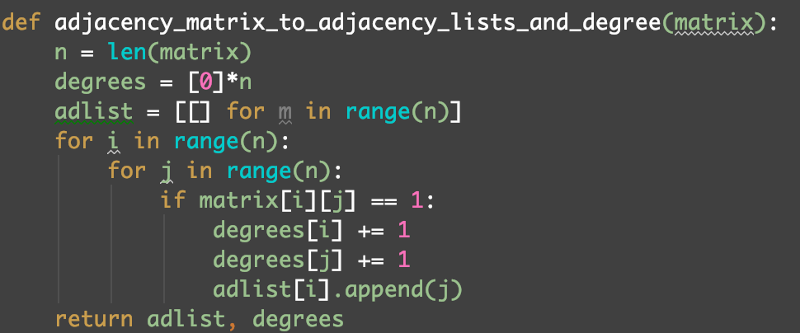

Test:

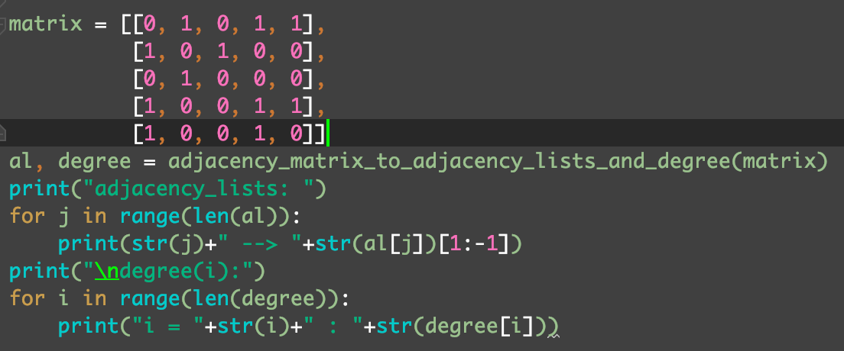

Output:

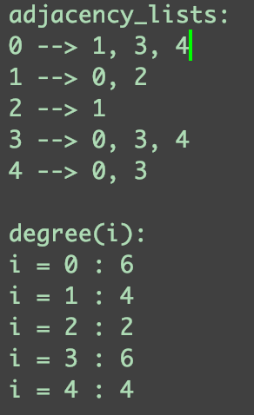

**1.2 Given a directed Graph (V, E), in Adjacency Matrix, generate its MultLists, using it to calculate and print out degree(i).**

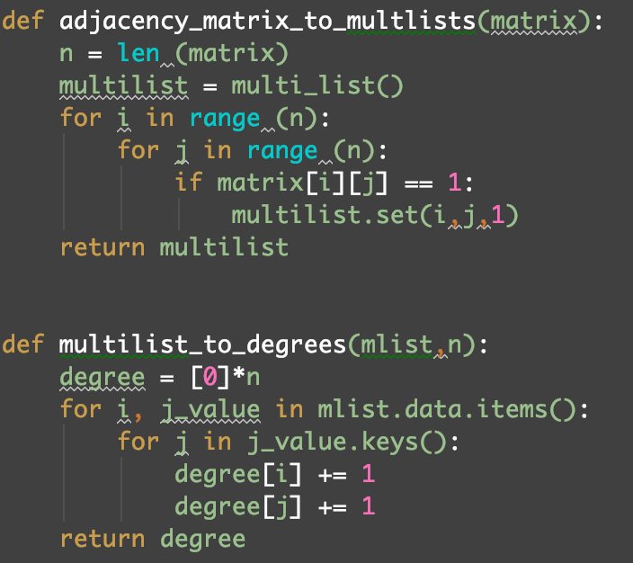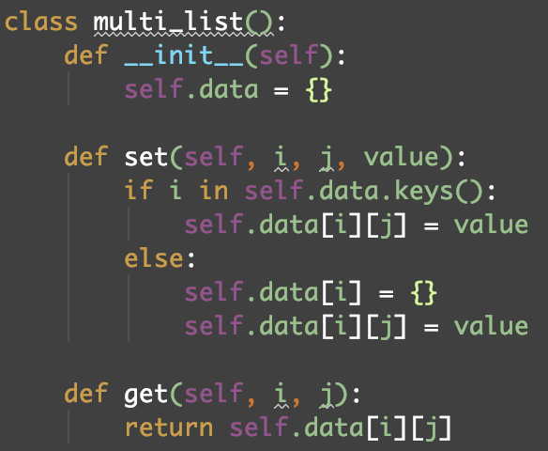To generate the multlists with adjacency matrix, we need to get every “j” for each “i” such “adjacency matrix[i][j]” equal to the 1 and store the “j” and “i” into the multlists. Then, for every single “i”, the number of relevant “j” in the mutilists is the “degree[i]”.

Test:

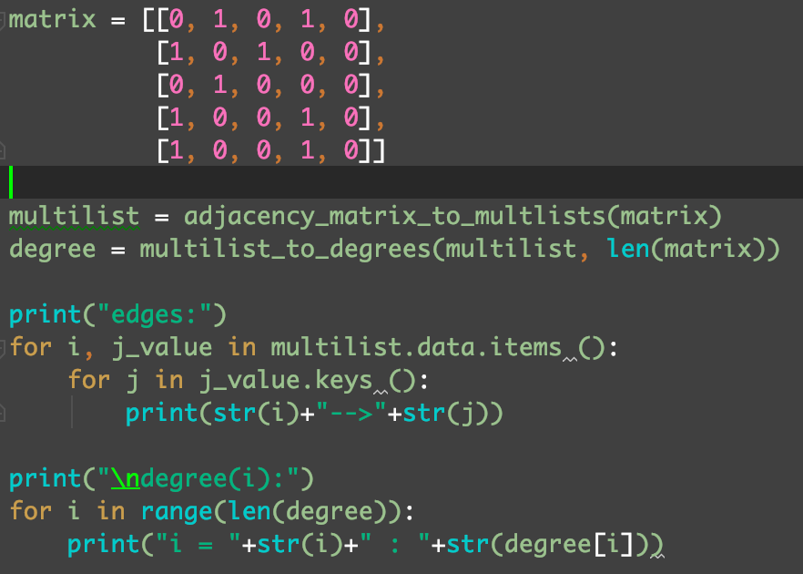

Output:

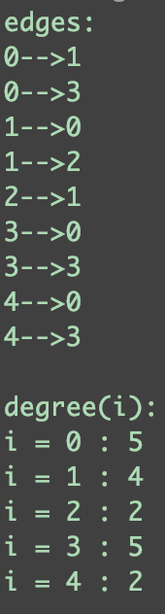

**1.3 Given an AOV network, generate and print a topological order if possible.**

Remove the node with 0 indegrees form the node and reset indegrees of the nodes that relevant to the removed node. Repeat the operation until all of the nodes are removed from the graph.

Test:

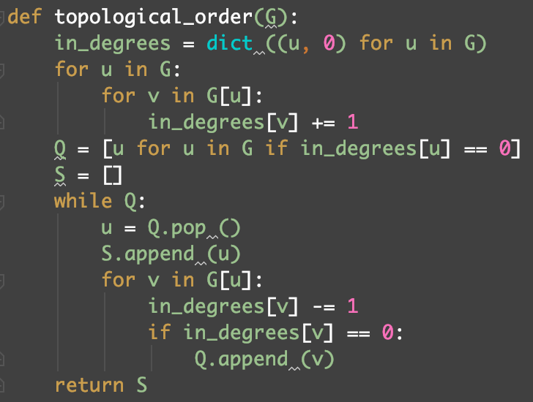

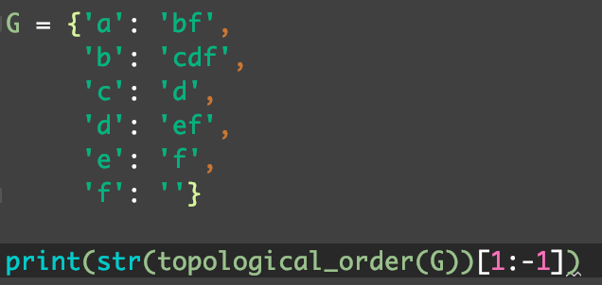

Output:

